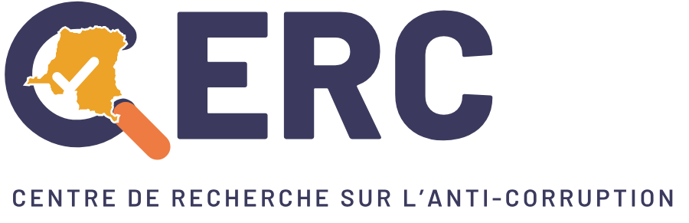 | 

HealthCheck · Edition 2026
Citizen monitoring report on health facilities
HealthCheck — results, analysis and recommendations

Scope : All provinces, whole period
Date : 2 November 2026

Prepared by the Anti-Corruption Research Centre (CERC)
sante.cerc.cd · info@cerc.cd

Contents
1. About CERC
2. HealthCheck
3. Why HealthCheck matters
4. Key figures and findings
5. Statistical analysis by category
6. Further analysis
7. Recommendations
8. Letter to the Minister of Health

1. About CERC
The Anti-Corruption Research Centre (CERC) is a Congolese public-interest organisation based in Kinshasa and Bukavu, working with citizens to strengthen integrity, transparency and good governance of public services in the Democratic Republic of the Congo.
Since 2017, CERC has trained citizens to monitor public services: schools with EduCheck, health facilities with HealthCheck. Its method relies on verified, published facts and on constructive dialogue with officials until problems are solved.

2. HealthCheck
HealthCheck is CERC’s citizen monitoring platform for health facilities. In each health area, CODESA members trained by CERC form a health committee that regularly visits health centres, hospitals, clinics, dispensaries and pharmacies.
Committees, patients, carers and health workers report the problems they see. CERC checks every report before publication; the facility management is informed and asked to act; the committee talks with the managers and confirms the fix on site. Every step is public, without ever publishing a reporter’s name or individual medical data.
CERC’s approach — CERC identifies and trains CODESA members in each health area. Their health committee monitors health facilities with HealthCheck, reports problems, talks with the facility managers and the health zone, and checks each fix on site. Reports are checked by CERC before publication; reporters’ names are never published.

3. Why HealthCheck matters
Ministry of Health
A real-time, verified and geolocated view of service quality in health facilities, to guide inspection, budgets and priorities, and to measure the effect of reforms.

NGOs and technical and financial partners
Field evidence to target interventions, follow the use of support and report results with a resolution rate verified on site.

Civil society
A social accountability tool: open, downloadable data to document advocacy and engage authorities on the basis of facts.

Patients and communities
A protected voice to report illegal fees, medicine stock-outs, poor reception or detention for debt, and the possibility to follow each problem until it is solved.

Health workers
A channel to raise system failures — stock-outs, broken equipment, unpaid salaries — and to show publicly the fixes obtained.

4. Key figures and findings
0  health facilities monitored | 2  active health monitors | 1  problems reported
0 %  of problems fixed | —  days: median time to fix | 0  monitoring visits

Findings
- « Health financing and public funds » is the most reported area: 1 problems, 100 % of the total.
- 0 % of the problems reported have been fixed or resolved (0 of 1).

Problems by area

5. Statistical analysis by category
For each area: problems reported, share of the total, resolution rate, median time to fix, most frequent problems and the mechanisms that solved them.

Health financing and public funds
1  Reported | 100 %  Share of total | 0 %  Resolution rate | —  Median time (days)
Most frequent problems  - Fonds d’urgence non retracés dans la riposte contre Ebola (1) | Most effective resolution mechanisms  - —

6. Further analysis

Status of problems

Reported and fixed per month

Who monitors?

Women : 0 % · Men : 0 % · People living with a disability : fewer than 5 · LGBTQI people : fewer than 5

7. Recommendations
1. Citizen monitoring — Extend health committees trained by CERC to every health area, and keep the dialogue with facility managers and the health zone until each problem is verified on site.

8. Letter to the Minister of Health
Kinshasa, le 2 novembre 2026
N/Réf. : CERC/HC/2026/____

À Son Excellence Monsieur le Ministre de la Santé publique, Hygiène et Prévoyance sociale
Ministère de la Santé publique, Hygiène et Prévoyance sociale
Kinshasa / Gombe
République démocratique du Congo

Objet : Transmission du rapport de suivi citoyen des structures de santé (HealthCheck) et recommandations

Excellence Monsieur le Ministre,
Le Centre de Recherche sur l’Anti-Corruption (CERC) a l’honneur de vous transmettre le rapport de suivi citoyen des structures de santé réalisé à travers la plateforme HealthCheck (All provinces, whole period).
Dans les 0 structures de santé suivies, les comités de santé formés par le CERC, appuyés par 2 moniteurs, ont signalé 1 problèmes vérifiés. 0 % des problèmes ont déjà été corrigés ou résolus, avec un délai médian de — jours, grâce au dialogue avec les responsables des structures et des zones de santé.
Les domaines les plus signalés sont : Health financing and public funds. Ces problèmes touchent directement l’accès des populations à des soins de qualité, en particulier des femmes, des enfants et des ménages les plus pauvres.
Au vu de ces constats, le CERC recommande respectueusement à votre Ministère de :
1. Extend health committees trained by CERC to every health area, and keep the dialogue with facility managers and the health zone until each problem is verified on site.
Le CERC se tient à votre disposition pour présenter ces résultats à vos services, partager les données détaillées par province et par zone de santé, et contribuer au suivi des mesures qui seront prises.
Nous vous prions d’agréer, Excellence Monsieur le Ministre, l’expression de notre très haute considération.

Pour le Centre de Recherche sur l’Anti-Corruption
Le Directeur exécutif
Heri Bitamala

Copie pour information : Secrétariat général à la Santé ; Inspection générale de la Santé ; Divisions provinciales de la Santé concernées ; Partenaires techniques et financiers.
Template letter, to be adapted and signed by CERC before sending (in French, the administrative language of the DRC).

